MATLAB Assignment 2

Submitted by Subhang Vempati

Question1:

Problem a:

Problem b:

Provided condition is that angular momentum is measurable. This means we are trying to control the angular momentum of the pendulum. Initial conditions for the pendulum is the Position of the cart is X= 0, velocity of the cart first derivative of X i.e, x_dot = 0, initial angle of the rod of the pendulum Theta is 20 degrees , first order derivative of the angle is Angular acceleration theta_dot is 0.

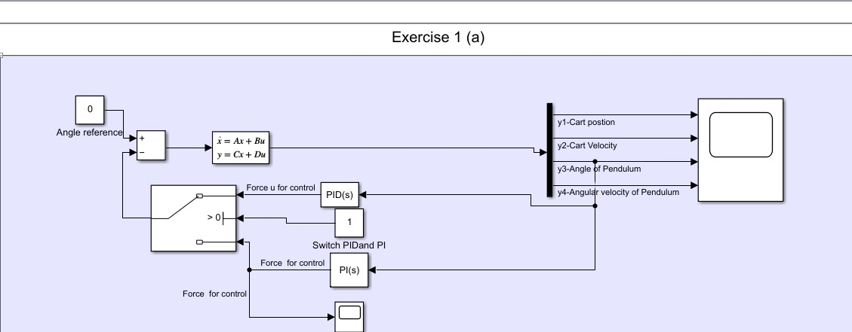

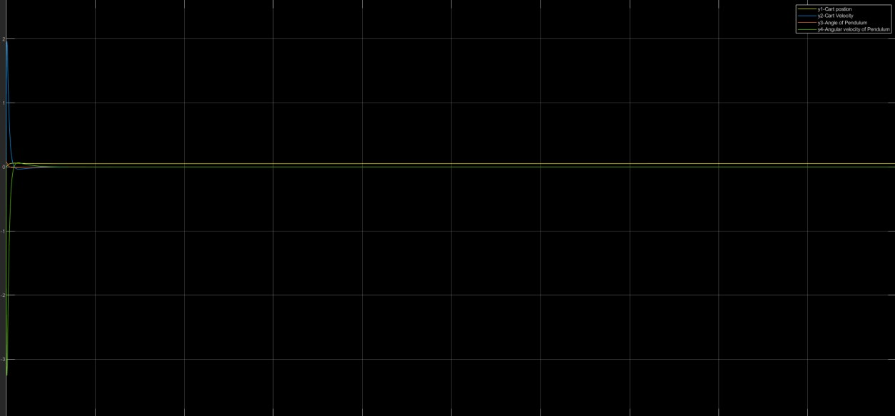

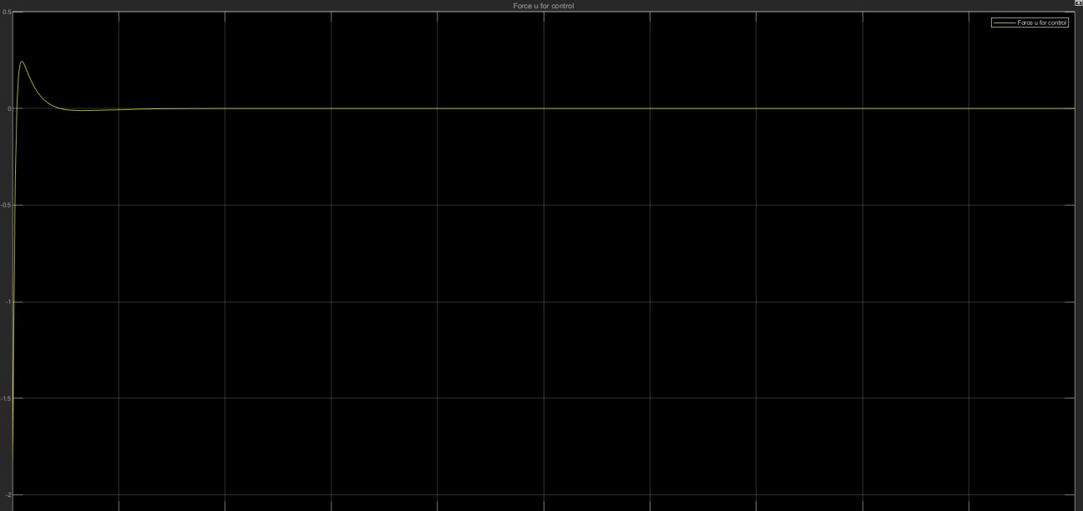

Problem c:

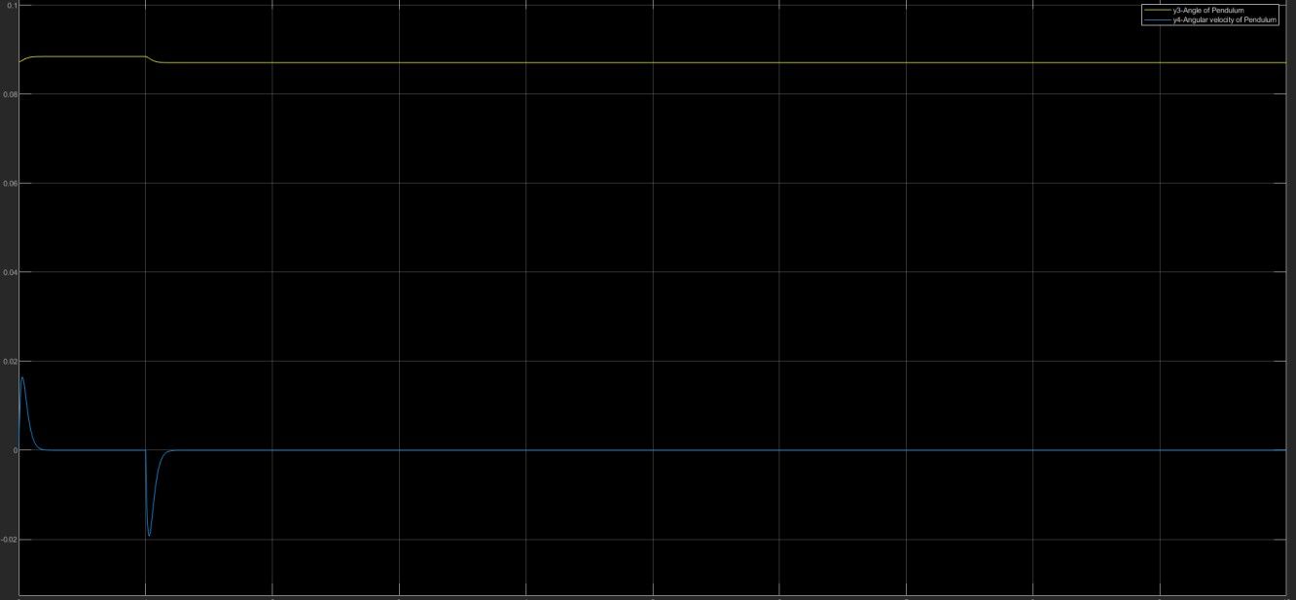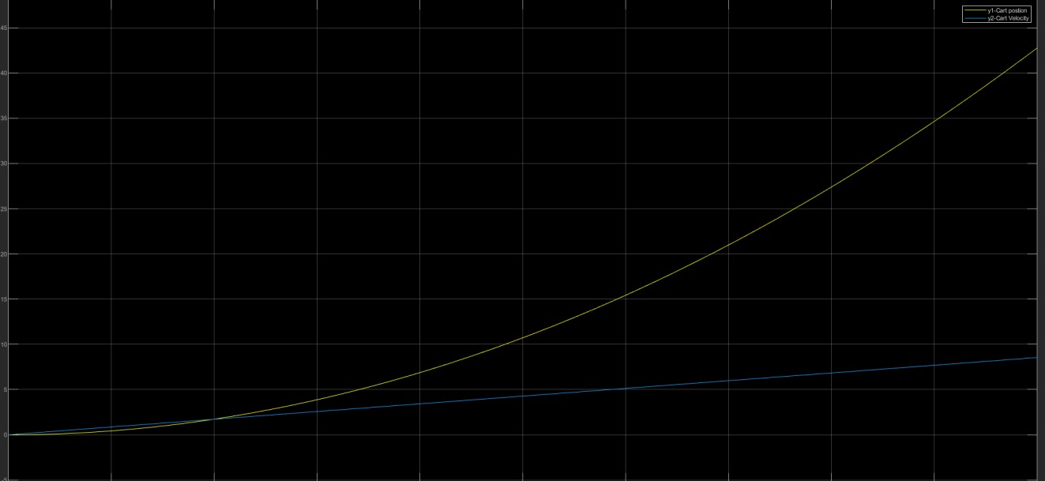

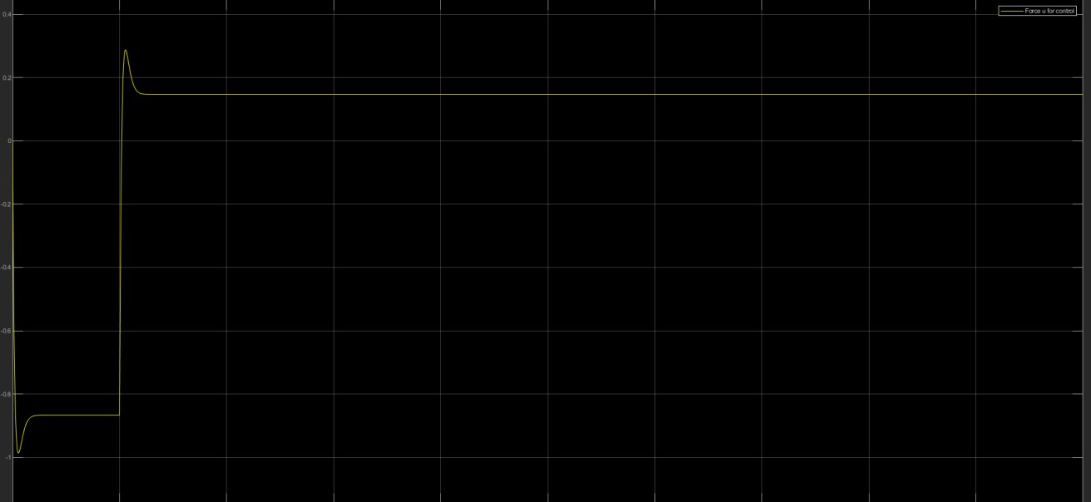

Exercise 2

Problem a.

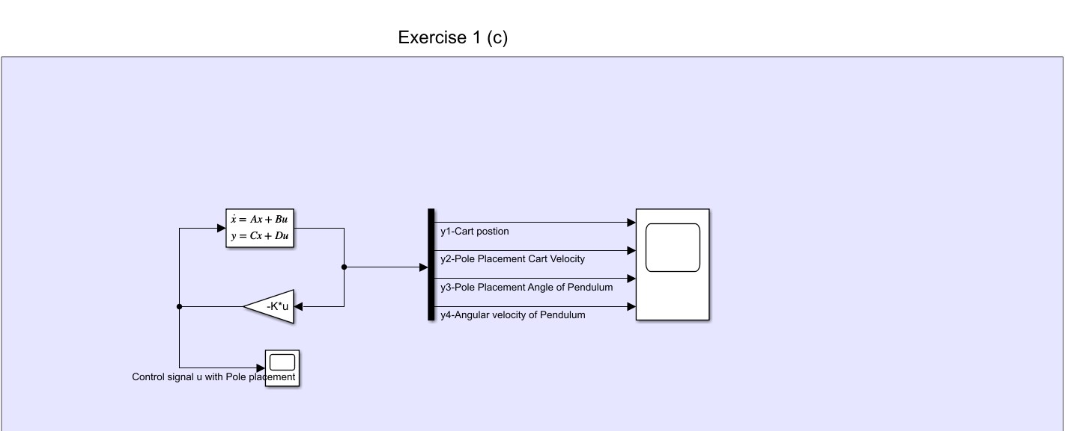

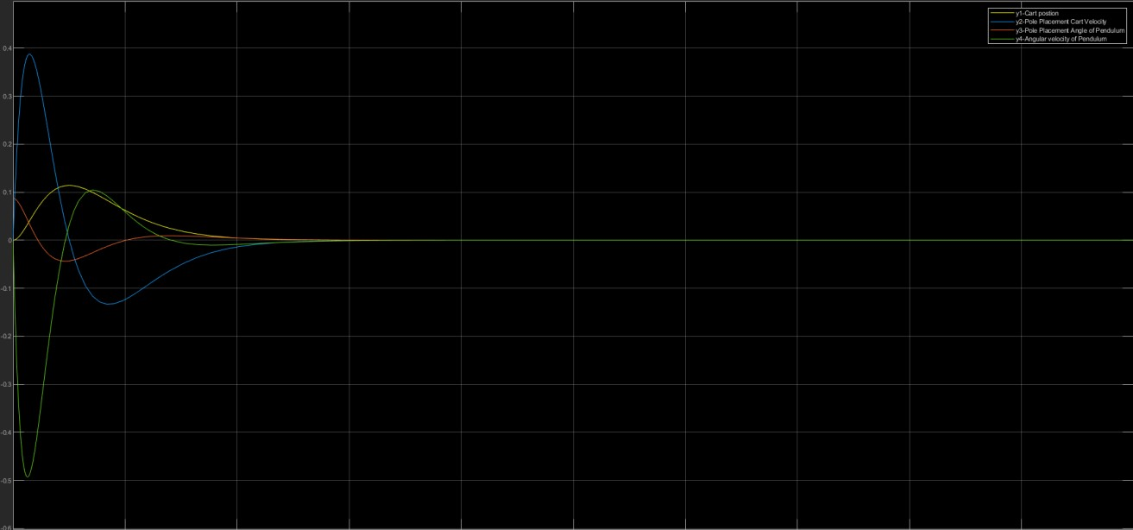

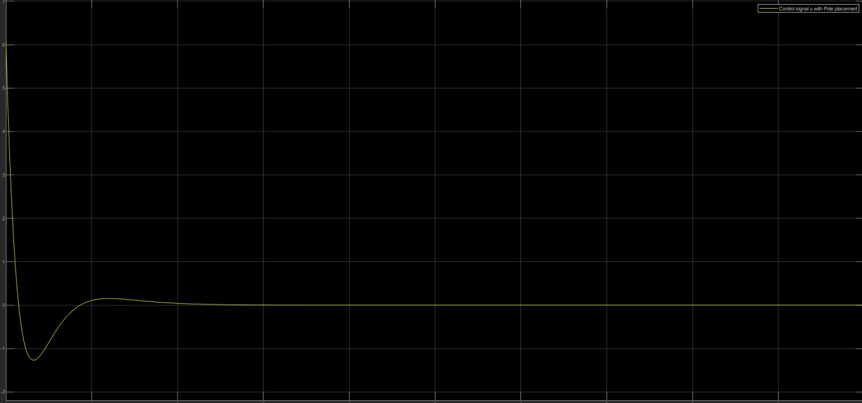

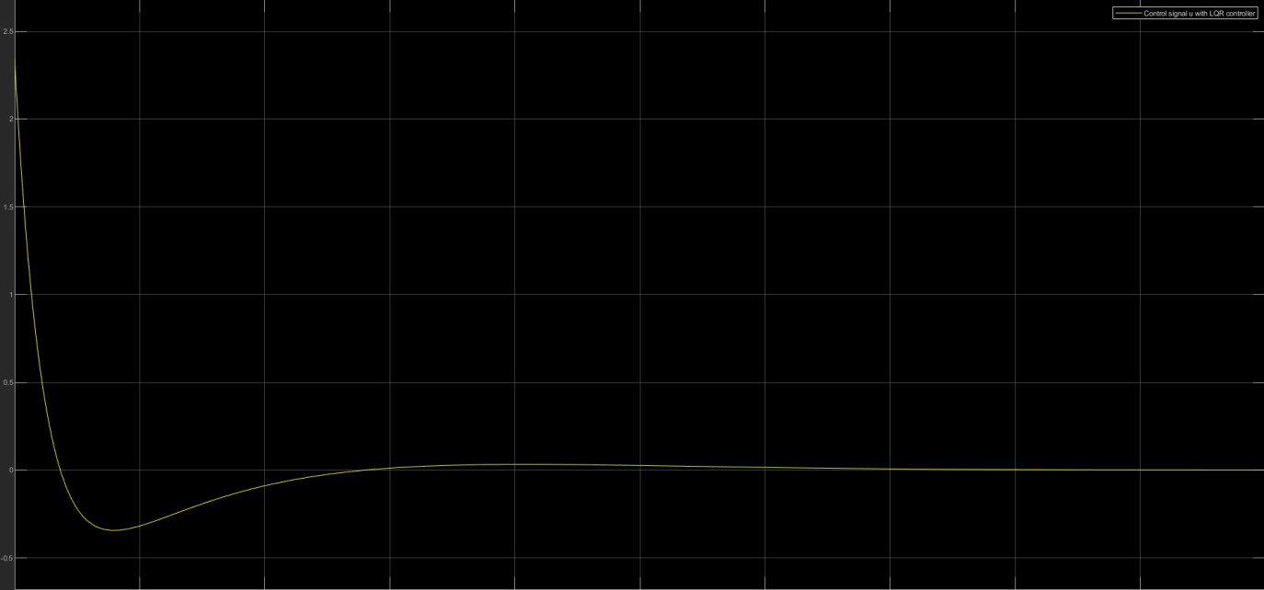**b.**

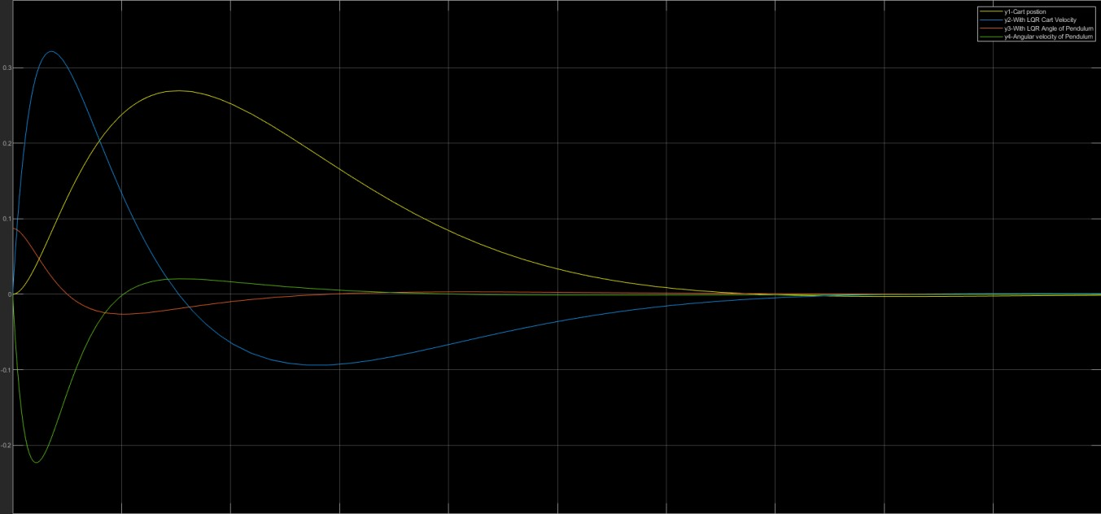

Problem 2:

I have used tocks for the timer that counts back in the oven and will get activated when start button gets pressed in the oven and named it the oven-timer. In Oven module you can control UP and Down buttons in the oven.

The cooking state will take care of the start, Door and stop buttons on the oven. Alarm is set to be a LED lamp where 0 is on cooking timer Alarm light will light up green.

Problem 3:

